**Chamras Nakiraks (1917-2002)**

Chalerm Nakiraks was a Thai painter whose signature paintings were those executed in water-colours, of realistic landscapes including Thai temples, floating markets, traditional Thai houses as well as those illustrating the history of the nation and the Thai monarchy. In this way, his paintings were seen as serving the promotion of Thai nationalism and Thai identity. These circumstances resulted in him being awarded the title National Artist for Visual Arts (Painting), in 1988.

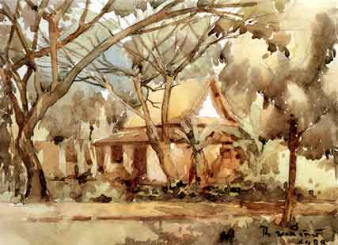

Chalerm Nakiraks, *Temple Among the Trees*, 1945, watercolour on paper, 26 x 38 cm, Collection of Dr. Thaksin Shinawatra.

Chamras started his art training at Rongrien Phochang (The Arts and Crafts School) in 1935 under Professor Prakit (Chit) Buabusaya, a pioneering Impressionist painter in Thailand. He had also practiced Thai traditional painting under the guidance of Phra Thevapinimitr, a veteran Thai traditional painter. Amongst his other influential teachers was Niro Yogota, a Japanese painter who initiated the genre of water-colour depictions of Thai canal life, paddling boats, floating markets and houses. After his graduation in 1947, Chalerm joined the teaching members of Rongrien Phochang and remained there until his retirement.

Chalerm had played significant part in the Modern art movement in Thailand since its inception as a tool to modernize the country. In this way, Chalerm adhered strongly to Prof. Silpa Bhirasri’s view that Thai art should utilize elements of Western art but remain true to Thai identity. This was most significantly reflected his participation in the Constitutional Celebration Art Contest during 1940-1942. In 1944, Chalerm joined other artists of various disciplines in the initiation of the first Thai artists’ group exhibition known as Chakrawat Silapin Group (The League of Artists). He had also played a vital role in the revival and assimilation of Thai traditional painting with Modern art practice. In 1963, Chalerm and his artist peers held a painting exhibition that demonstrated the revival of Thai traditional art, and eventually developed into the neo-traditional art practices of later generations of artists.

**List of Works**

Rama 9 Art Museum. *Chamras Nakiraks*, [online], Available online: <http://www.rama9art.org/chalerm/> (This website includes images held in the Rama Art Collection and brief biographical information about the artist)

**Biography and Further Reading**

Apinan Poshyananda. (1992) *Modern Art in Thailand: Nineteenth and Twentieth Centruries*, Singapore: Oxford University Press.

Apinan Poshyananda, et al. (2007) *Show Me Thai* (Exhibition Catalogue), Tokyo: Museum of Contemporary Art.

Bangkok Art and Culture Centre, *Krungthep 226: The Art from Early Days Bangkok to the Imagined Future* (Exhibition Catalogue), Bangkok: Bangkok Art and Culture Centre.

Chalerm Nakhirak. (2000) *84 Pi Chatakan Sattrachan Chalerm Nakiraks: Sinlapa Heng Chat* (Life and Works of Prof. Chalerm Nakiraks: National Artist of Thailand), Bangkok: Samakhorn Sit Kao Phochang.

Pitakpol Wisuthumporn, ed. (2006) *Art in the Reign of King Rama IX: 6 Decades of Thai Art* (Exhibition Catalogue), Bangkok: Rama IX Art Museum Foundation.